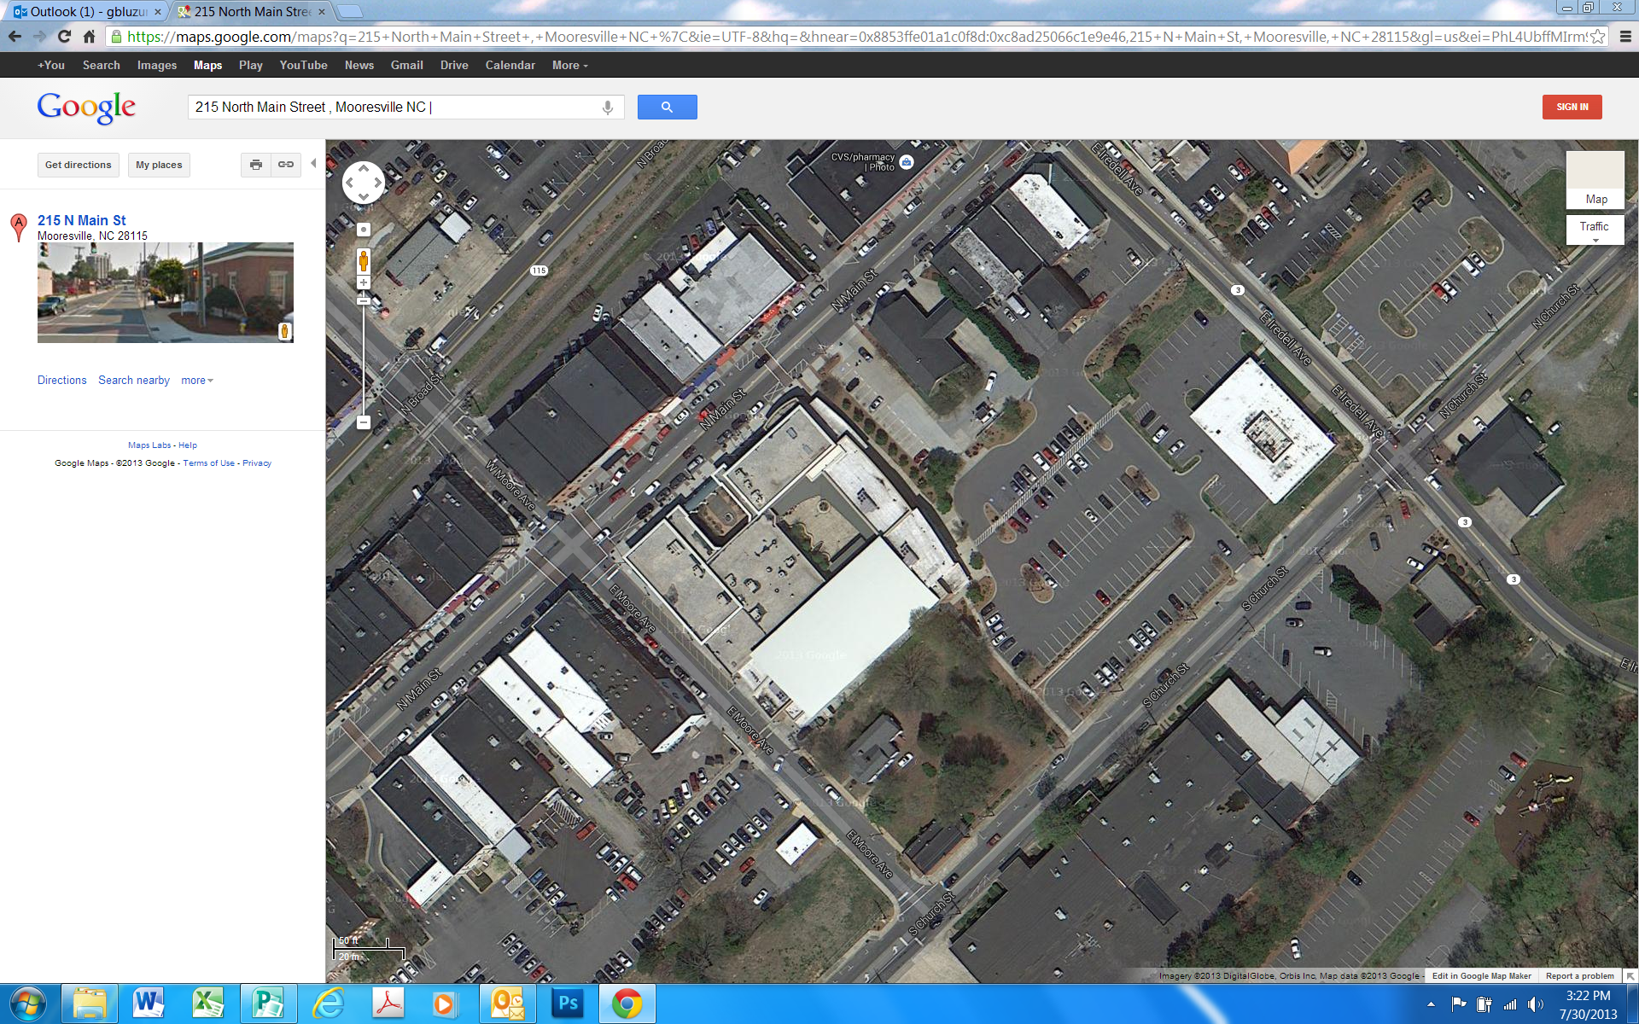

*

**CHARLES MACK C.★C.**

**IREDELL AVE. (HWY. 3)**

**CHURCH STREET**

**MOORE AVE. **

**Private Parking**

**Private Parking**

**Public Parking**

**Public Parking**

**This section Wells Fargo Parking Only**

**Public Parking**

**Main Street (2 Hour Parking Only)**

Charles Mack Citizen Center: 215 N. Main Street, Mooresville, NC 28115